**Percentiles and Quantiles:**

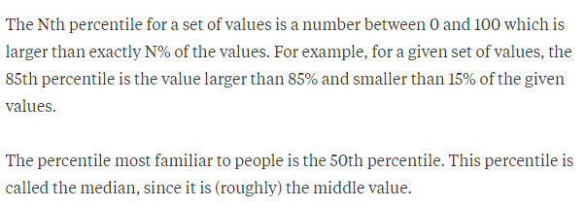

Percentile actually tells us how with how much %age the value is larger and by how much %age the value is smaller.

A more detailed ex of percentile is given in below fig:

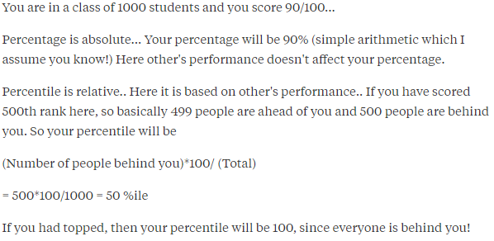

Formula to calculate Percentile

***Percentile = (number of people behind you/total number of people) x 100***

So on the basis of above explanation we can say that 50th percentile is the median value.

As you can see in below fig you have 100 values, first you sort them in ascending order, now to find 50th percentile you directly see to the 50th position because total data are 100 and 50 is middle, and similarly the median for these 100 data is also present at 50th position.

**Quantiles:**

Quantiles are nothing but 25th percentile, 50th percentile, 75th percentile and 100th percentile.

How to calculate 25th percentile, it’s median of data between 0th to 50th percentile, similarly 75th percentile is the median of 50th and 100th percentile.

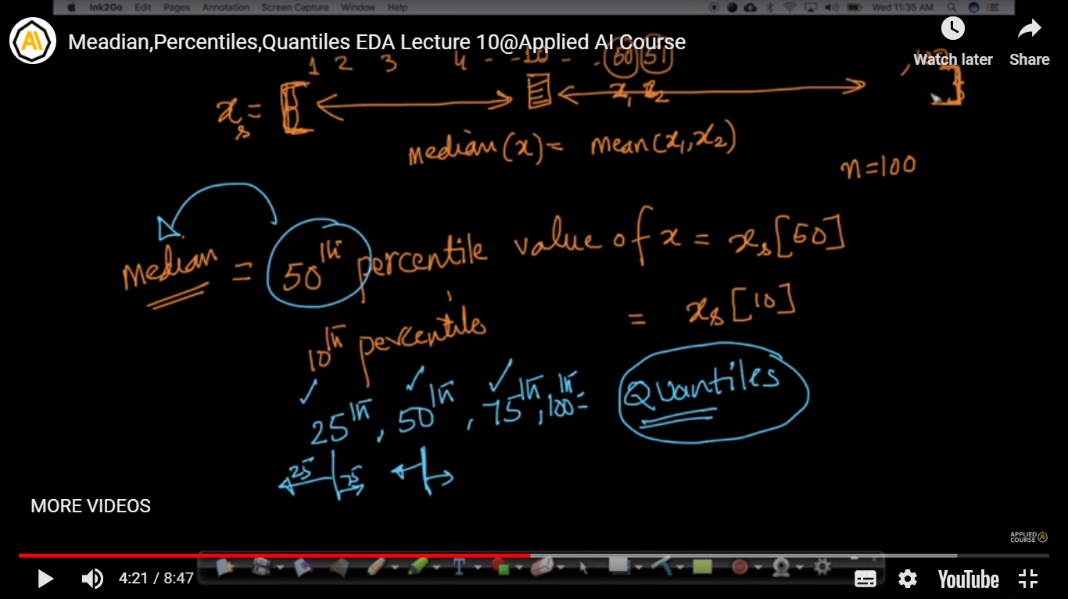

Below fig shows calculating 0th, 25th, 50th and 75th percentile.

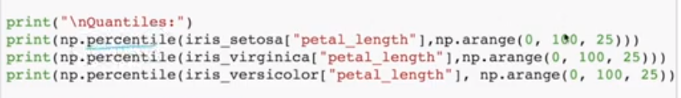

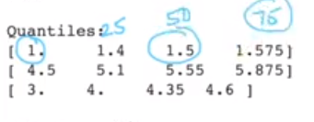

In some scenarios 90th percentiles is also very useful, ex: for an ecommerce company there are a data of delivery times in days for 10k customers, now by seeing at 90th percentile we can say in how many days 90% of population are getting delivery.

In below fig 95th and 99th percentile is give: here 95th percentile people get delivery in 4 days and rest 5% are not getting delivery after a 1.6 days delay so we can dig more in those 5% customers to find out the reason.

